Budget Rent-a-Car
of British Columbia

Inter-branch Accounting Tutorial

Version 1.00

Note: The information contained in this document is confidential and may not be disclosed to any parties outside of Budget Rent-a-Car of British Columbia Ltd. without written consent by one of its officers.
Copyright (C) 2010 Budget Rent-a-Car of British Columbia Ltd.
TABLE OF CONTENT

1 Introduction 1
2 Inter-branch Internal Walkthrough 2
3 Exporting IB Entries 13

1 Introduction

Inter-branch (IB) transactions occur when Budget deals with foreign locations or foreign vehicles. Specifically, IB transactions come into action when at least one vehicle involved in any Budget’s contract is picked up or dropped off at a foreign location. Another scenario that applies to inter-branch is when a foreign vehicle is used throughout the lifecycle of any Budget’s contract.

There are three main IB transaction types:

1) Local Rental - Renting Company rents a vehicle which belongs to another company (Owning Company) locally, i.e. among the Renting Company’s rental locations.

For example, Budget rents a minivan (owned by Budget Victoria) to a customer who picks it up in Downtown and returns it to YVR Airport, both of which belong to Budget.

2) One Way – Owning Company of the vehicle sends the vehicle to a rental location which belongs to another company (known as the Receiving Company).

For example, a customer rents a Full Size 4Door (owned by Budget) from YVR Airport (also owned by Budget) and drops it off at Seatac Airport, which is a Budget Seattle rental location.

3) Rent Back – Renting Company rents a foreign vehicle back to any location which belongs to the vehicle’s Owning Company. It also includes any scenario which is neither a local rental nor a one way.

For example, Geordy Rentals Inc. rents a Hybrid Full Size (owned by Budget) to a customer who picks it up at Abbotsford Airport, which is Geordy’s rental location and drops it off at Downtown (owned by Budget).

NOTE
The example given above is a rent back if seen from Budget’s perspective because our vehicle is being rented back to us. If a foreign vehicle is rented at a Budget location and returned to a location belonging to the vehicle’s Owning Company, we call it a Send Back.

For example, Budget rents a Mid-Size SUV (owned by Phelps Leasing Ltd.) to a customer who picks it up at YVR Airport (owned by Budget) and drops it off at Kingsway (owned by Phelps Leasing Ltd.).

Please note that we categorize both rent back and send back under the same transaction type – Rent Back.

By the end of this tutorial, you will have learnt how GIS generates IB accounting entries internally and how you can generate and export them into ACCPAC.

2 Inter-branch Internal Walkthrough

Since inter-branch involves Budget and other companies, each company has individual agreements with Budget on how the revenue should be split.

Rental locations are categorized into different inter-branch (IB) zones based on where they are located. For Budget, there are four zones:

1) LC – Local

All Budget’s rental locations will belong in this zone.

2) LM - Lower Mainland

Includes all rental locations in the lower mainland, i.e. Vancouver, Burnaby, Surrey, Coquitlam, Richmond, Langley, White Rock, Chilliwack, Maple Ridge.

3) US - United States

Includes all rental locations in Seattle and Bellingham.

4) BA - BC/Alberta/Abbotsford/North Van

All rental locations in Abbotsford, North Vancouver and Alberta belong in this zone. Any city within British Columbia not covered in the LM zone also belongs here.

NOTE
For Geordy Rentals, there is an additional zone called the OW (One Way Truck).

For inter-branch accounting to work in GIS, each company is first assigned with an IB zone. Then, each company’s rental location is also assigned with an IB zone. Note that the default IB zone for all rental locations is their owning company’s IB zone.

For example, Budget’s IB zone is BC and the IB zones of its two rental locations (YVR Airport and Downtown) default to BC as well.

The revenue of a contract comes from rental billing items such as rental revenue, loss damage waiver, personal accident insurance, personal effect coverage, location fee, drop charge, baby seat, additional driver, ski rack, fuel/FPO etc. In inter-branch however, the revenue for each rental billing item in a contract involving multiple companies is generally split among those companies. This is essentially the most important part of inter-branch - how the revenue from each rental billing item is split. All you need to do in GIS is enter the revenue split percentage for each rental billing item for different scenarios (e.g. local rental, one way) and leave it to GIS to generate all the IB accounting entries.

Before we dive into the topic of revenue splitting, we would like to take you on an internal GIS tour to see and learn how GIS magically deals with inter-branch.

Understanding IB Transaction Type and Revenue Ownership

We have developed an internal set of logics, as shown in Figure 1 to correctly determine who the payee and the payer are for the total revenue in a contract. You must first assume that the entire revenue belongs to one party. From there you can slowly sort out the revenue splitting for each rental billing item.

Each row represents a rental scenario (highlighted in gray) and is made up from two conditions: IB transaction type (a combination of Owned by Me, Rented by Me and Received by Me, where ‘Me’ refers to you as a rental company) and Revenue Ownership. We will ignore the IB Zone of column for now. Try studying this table from your perspective as a rental company and you will understand who you should pay the revenue to and who you should receive it from. We will walk you through each scenario to give you a better understanding.

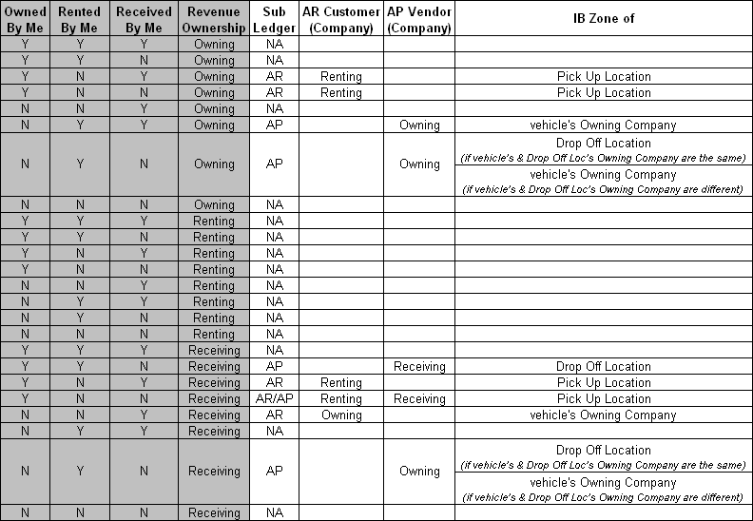
Figure 1: The inter-branch accounting matrix presents the interaction between transaction type and revenue ownership, versus the sub ledger and the corresponding customer/vendor. (Y = Yes; N = No)

Make sure you understand the three transaction types we mentioned earlier in the tutorial, because the upcoming inter-branch examples are going to build on them.

IMPORTANT
All customer payments are processed at the Renting Company. In other words, the Renting Company is responsible for transferring any revenue that belongs to its rightful owner (either the Owning or Receiving Company). Do not worry if you don’t get it now, just bear in mind that the Renting Company holds all the revenue because payments are processed during vehicle check outs.

NOTE
The three conditions below – Owned by Me, Rented by Me and Received by Me are named that way so that the scenarios can be seen your perspective.

If Rented by Me is a ‘Y’, you are the Renting Company and vice versa.

If Owned by Me is a ‘Y’, it means that you are the Owning Company.

If Received by Me is a ‘Y’, it means that you are the Receiving Company.

- Owned by Me=Y; Rented by Me=Y; Received by Me=Y; Rev Ownership=Owning
Your vehicle is both picked up and dropped off at your locations. Since the revenue belongs entirely to you and the rental process does not involve any foreign company, it is not an inter-branch transaction at all! A tricky way to start our examples!

- Owned by Me=Y; Rented by Me=Y; Received by Me=N; Rev Ownership=Owning
This rental scenario is similar to the first one with the exception of the drop off location. Doesn’t this look like a one-way? Absolutely, since you are sending your vehicle from your rental location to a foreign one. The fourth parameter states that the revenue ownership belongs to the Owning Company, which is you. Here, the revenue will be dealt with internally since you are currently in possession of the customer payment and the revenue belongs to it as well. Therefore, the accounting for this transaction is an internal issue and does not involve any inter-branch.

- Owned by Me=Y; Rented by Me=N; Received by Me=Y; Rev Ownership=Owning
This is a typical rent back scenario. Even though you as the Owning Company did not rent your vehicle, the condition indicates that the revenue belongs to you. This in turn means that the Renting Company has to pay you all the revenue it collected for this particular rental. Therefore, your GIS will treat this transaction as accounts receivable.

- Owned by Me=Y; Rented by Me=N; Received by Me=N; Rev Ownership=Owning
This scenario is a little vague since it does not specify whether or not the Renting Company is the same as the Receiving Company. If they are the same company, this would be a local rental where a foreign company rents your vehicle locally. If they are different, then this becomes a rent back scenario. In either case, the customer’s payment is sitting at the Renting Company but it is supposed to be yours. So once again, you need to collect the revenue from the Renting Company and GIS credits the revenue as accounts receivable.

- Owned by Me=N; Rented by Me=N; Received by Me=Y; Rev Ownership=Owning
This is the scenario of our one way rental (in the second example above) seen from the Receiving Company’s perspective. The conditions show that the revenue ownership and payment processing do not involve you so no inter-branch accounting is involved.

- Owned by Me=N; Rented by Me=Y; Received by Me=Y; Rev Ownership=Owning
This is an example of a local rental at your company. The customer payment you collected upon vehicle check out, however, legally belongs to the Owning Company. Therefore, your GIS will debit the revenue from this transaction as accounts payable and transfer it to the Owning Company.
- Owned by Me=N; Rented by Me=Y; Received by Me=N; Rev Ownership=Owning
This is another vague scenario since you do not know whether or not the drop off location’s Owning Company is the same as the Owning Company of the vehicle you rented. If they are the same, then you are essentially sending back a foreign vehicle to its Owning Company. Recall that a send back is just the opposite of a rent back and is this categorized under the latter. GIS will treat this transaction as accounts payable for you since you have to return the revenue you processed for this transaction to the Owning Company. We will deal with the case when both companies are different later in the chapter.

- Owned by Me=N; Rented by Me=N; Received by Me=N; Rev Ownership=Owning
Inter-branch is not applicable here since you are not involved with the rental at all.

NOTE
The scenarios from 9 onwards are a repetition of the previous eight. The only difference being the revenue ownership. If you feel confident about the IB accounting examples here, feel free to skip to the next section.

- Owned by Me=Y; Rented by Me=Y; Received by Me=Y; Rev Ownership=Renting
Observe that the entire rental only involves you, the A/R and A/P can be automatically cleared.

- Owned by Me=Y; Rented by Me=Y; Received by Me=N; Rev Ownership=Renting
This is a one way scenario. However, seeing that the revenue belongs to you and the revenue is already in your possession, there is no need for any inter-branch accounting.

- Owned by Me=Y; Rented by Me=N; Received by Me=Y; Rev Ownership=Renting
The revenue here belongs to the Renting Company. Since you did not rent the vehicle, the customer payment is processed and kept by the Renting. This means that accounting for that revenue will only be done internally in the Renting Company.

- Owned by Me=Y; Rented by Me=N; Received by Me=N; Rev Ownership=Renting
See explanation in scenario 11 above.

- Owned by Me=N; Rented by Me=N; Received by Me=Y; Rev Ownership=Renting
See explanation in scenario 11 above.

- Owned by Me=N; Rented by Me=Y; Received by Me=Y; Rev Ownership=Renting
This case is the opposite of scenario 11. Considering that you rented a foreign vehicle and own the entire revenue from that rental, accounting will be done internally on your end.

- Owned by Me=N; Rented by Me=Y; Received by Me=N; Rev Ownership=Renting
You need only produce internal accounting entries seeing that the revenue from the rental you processed belongs to you alone.

- Owned by Me=N; Rented by Me=N; Received by Me=N; Rev Ownership=Renting
You do not need to produce accounting entries for a rental in which you are not involved in.

- Owned by Me=Y; Rented by Me=Y; Received by Me=Y; Rev Ownership=Receiving
If the entire rental involves you alone, your accounting will be done internally and not inter-branch.

- Owned by Me=Y; Rented by Me=Y; Received by Me=N; Rev Ownership=Receiving
In this one way scenario, since the money collected by you belongs to the Receiving Company, GIS treats this revenue as accounts payable and you have to pay the Receiving Company.

- Owned by Me=Y; Rented by Me=N; Received by Me=Y; Rev Ownership=Receiving
Since the revenue ownership belongs to you in this rent back, you should collect the revenue from the Renting Company. GIS will credit this transaction’s revenue as accounts receivable.

- Owned by Me=Y; Rented by Me=N; Received by Me=N; Rev Ownership=Receiving
This local rental presents a more interesting case. The revenue is owned by the Receiving Company but you neither rented nor received the vehicle. The first thought you might have is that the Renting Company pays the Receiving Company since it collected the money. But wait! If the Renting Company rents your vehicle, it will have to first transfer the revenue to you (See examples 3, 4, 6, 7). Therefore, GIS treats this revenue from the Renting Company as accounts receivable. However, the revenue’s legitimate owner is the Receiving Company so you will have to hand over the revenue to the Receiving Company. This explains why you have both an accounts payable and receivable.

- Owned by Me=N; Rented by Me=N; Received by Me=Y; Rev Ownership=Receiving
Let’s look at the first three conditions. Here, you cannot assume that both the Owning and Renting Companies are the same. If the Renting Company rents a car belonging to the Owning Company, it will first have to transfer the revenue to the latter (See examples 3, 4, 6, 7, 20). However, since you are the rightful owner of the revenue, you will receive the revenue from the Owning Company eventually. GIS will credit this revenue as accounts receivable.

- Owned by Me=N; Rented by Me=Y; Received by Me=Y; Rev Ownership=Receiving
Since you rented the Owning Company’s vehicle, you have to transfer the revenue you collected to the Owning Company. However, the revenue ownership belongs to the Receiving Company, which is you, so the Owning Company will pass the revenue back to you. Therefore, these A/P and A/R entries cancel each other off.

- Owned by Me=N; Rented by Me=Y; Received by Me=N; Rev Ownership=Receiving
Since you rented the Owning Company’s vehicle, you have to turn the revenue over to the Owning Company. The latter will transfer the revenue to the Receiving Company if they are different companies. Therefore, GIS treats this revenue as accounts payable.

- Owned by Me=N; Rented by Me=N; Received by Me=N; Rev Ownership=Receiving
You do not need to produce entries for a rental in which you are not involved in.

Now that you have understood the inter-branch accounting matrix, it’s time to walk you through the revenue split table and reveal how GIS generates inter-branch A/P and A/R entries with reference to them.

Revenue Splitting

You can create and adjust the revenue splitting settings using the GIS Maintenance tool which can be accessed from C:\Program Files\GIS\GISMaintenance.adp.

Let’s bring up the GIS Maintenance tool. Select Inter-Branch from the main menu (See Figure 2). Select Inter-Branch Revenue Ownership on the next screen to bring up the IB_Revenue_Split table. This table is known as the revenue split table and lists the revenue split percentage for each rental billing item depending on the type of ownership of revenue, IB transaction and the IB zone.

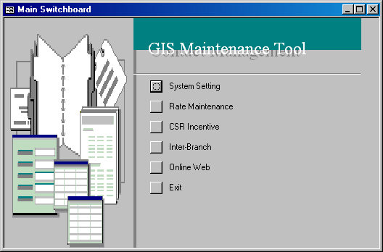
Figure 2: The main menu of the GIS Maintenance tool.

You can always add in a revenue source and its corresponding account number through ACCPAC, and this revenue source will be automatically added to the Revenue Account drop down list in IB_Revenue_Split (See Figure 3) for selection.

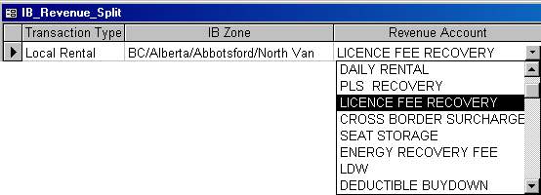
Figure 3: All sources of revenue are listed in the Revenue Account drop down list.
The inter-branch accounting matrix and the revenue split table complement each other. You would need to first lookup the inter-branch accounting matrix before you can make reference to the latter.

Let’s take a look at a local rental scenario below and you will see how the creation of inter-branch entries unfolds.

A customer rents a Budget intermediate car from Victoria Airport and returns it to the same location. When the vehicle is returned, the rental billing items listed on his check in contract include the vehicle rental amount ($79.98), location fee ($14.17), licence fee recovery ($3.98) and fuel ($21.50).

Assume that you are Budget and Victoria Airport is one of Budget Victoria’s rental locations. Ask yourself whether you own the vehicle, rent the vehicle and receive the vehicle? The combination of answers to these three questions will determine the type of IB transaction and the corresponding IB zone you need to use the revenue split table.

So in this scenario, OwnedByMe=Y, RentedByMe=N and ReceivedByMe=N. Next, we need to determine the transaction type based on these three parameters. You cannot assume that this Drop Off Location’s Owning Company is the same as the Pick Up Location’s Owning Company because it may not be the case. Since the scenario shows that the Pick Up and Drop Off Locations belong to the same company, this is a local rental. The IB zone we will use for the scenario OwnedByMe=Y, RentedByMe=N and ReceivedByMe=N is the pick up location’s IB zone (i.e. BA) according to Figure 1. Note that the Revenue Ownership field is irrelevant here.

Now that we know both the IB transaction type and IB zone, let’s look at the revenue split table to see how it works. Look for rows whose Transaction Type and IB Zone are ‘Local Rental’ and ‘BC/Alberta/Abbotsford/North Van’ (BA for short), as shown in Figure 4. Notice that a whole bunch of revenue accounts correspond to the transaction type and IB zone. Each of these revenue accounts represents a possible rental billing item on the contract. Recall that the items on vehicle rental amount, location fee, licence fee recovery and fuel.

We need to iterate the entire list of revenue accounts to determine the revenue split for each of our four items. Let’s start with the vehicle rental amount. First, look up the Revenue Account column and search for an item that indicates the rental. We have highlighted this record in black in Figure 4. Next, the Ownership column implies that the entire daily rental revenue belongs to the Owning Company. What about the last column that indicates a 10% commission rate? This means that even though the Owning Company is entitled to the entire revenue from the daily rental, it has to allocate 10% of the revenue as a commission to either the Renting Company or Receiving Company. But how do we know who receives the commission? Let’s look back at the inter-branch accounting matrix in Figure 1.

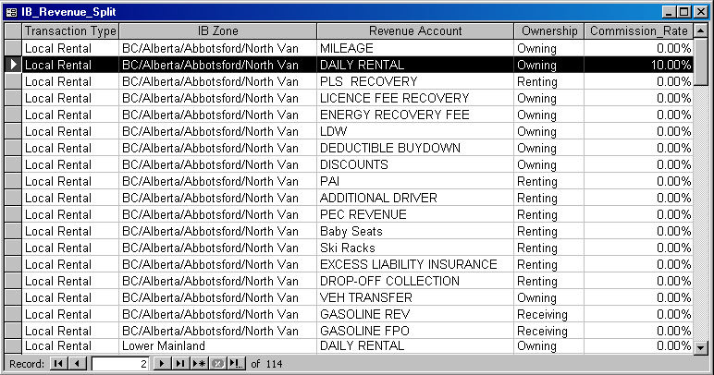
Figure 4: The revenue split table lists the revenue ownership, dependencies and commissions.

Recall that OwnedByMe=Y, RentedByMe=N and ReceivedByMe=N for our scenario and now we have an additional information – we have identified that the Revenue Ownership belongs to the Owning Company, which is you. With reference to these four parameters, the corresponding Sub Ledger and AR Customer (Company) columns point out that the Renting Company is responsible for transferring the revenue (See Figure 5). So there you go - whichever company that transfers the revenue is the company that will receive a commission (if any). In this scenario, you receive the daily rental revenue from the Renting Company and thus you have to pay the latter 10% of the revenue. Therefore, GIS will create an A/R entry for the daily rental revenue.

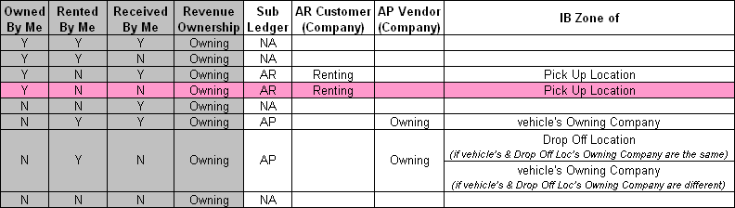
Figure 5: Determining who the revenue should be split with.
Next we determine who owns the location fee. Search through the list of revenue accounts in the revenue split table and notice that location fee (i.e. PLS Recovery) revenue belongs to the Renting Company with a 0% commission (See Figure 6). Location fees normally apply to specific locations and it is logical for the renting locations to keep that revenue. Now if you look back at the inter-branch accounting matrix, look for the same scenario - OwnedByMe=Y, RentedByMe=N and ReceivedByMe=N again but your Revenue Ownership this time should be ‘Renting’. Figure 7 shows that no IB entry will be created for the location fee revenue.

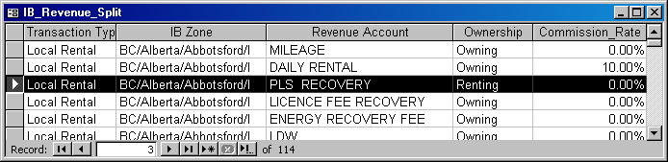
Figure 6: Revenue split for location fee.

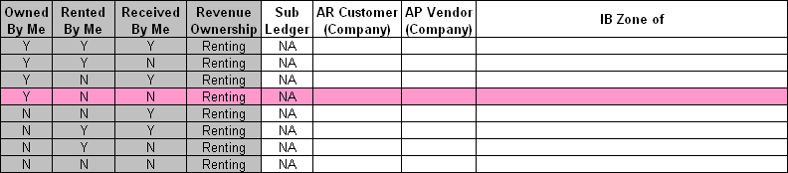
Figure 7: The IB accounting matrix indicates that no entry is generated for the highlighted scenario.

Looking at the revenue split table, you see that the licence fee recovery revenue belongs to the Owning Company with a 0% commission (See Figure 8). This means that the Owning Company owns the entire revenue from the licence fee. GIS will create a second A/R entry for this revenue.

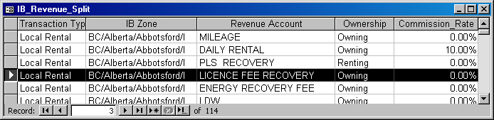
Figure 8: Revenue split for licence fee recovery.

The last item on the contract is fuel (or gasoline revenue) and it belongs to the Receiving Company entirely, as shown in Figure 9. Refer to the inter-branch accounting matrix again and look for the same scenario - OwnedByMe=Y, RentedByMe=N and ReceivedByMe=N. Your Revenue Ownership this time should be ‘Receiving’. Figure 10 shows that both A/R and A/P entries will be generated for the fuel revenue and the flow of revenue will start from the Renting Company to the Owning Company and back to the Receiving Company. However, recall that both the pick up and drop off locations are the same, so the A/R basically cancels off the A/P entry. So no IB entry is generated for this revenue.

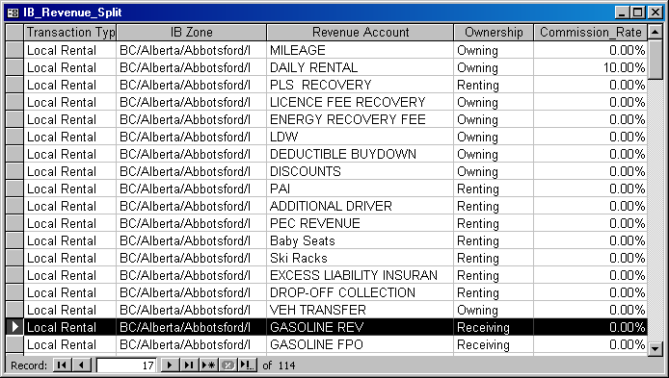
Figure 9: Revenue split for fuel.

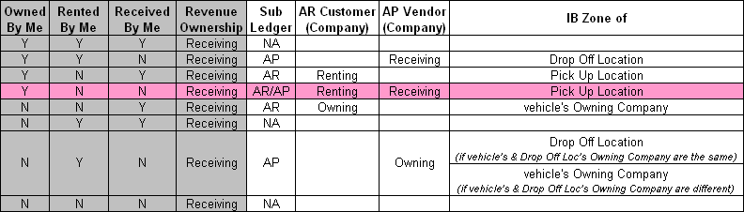
Figure 10: The IB accounting matrix indicates that two entries are generated for the highlighted scenario.

All the generated A/R entries for this contract are shown in Figure 11. We hope that was not too much to absorb. With these logics embedded within GIS, inter-branch entries are automatically created for any closed or adjusted contracts and stored in the GIS database after you close business day. In the next chapter, we will give you a step-by-step tutorial on how to close business day and how to export inter-branch entries as excel files.

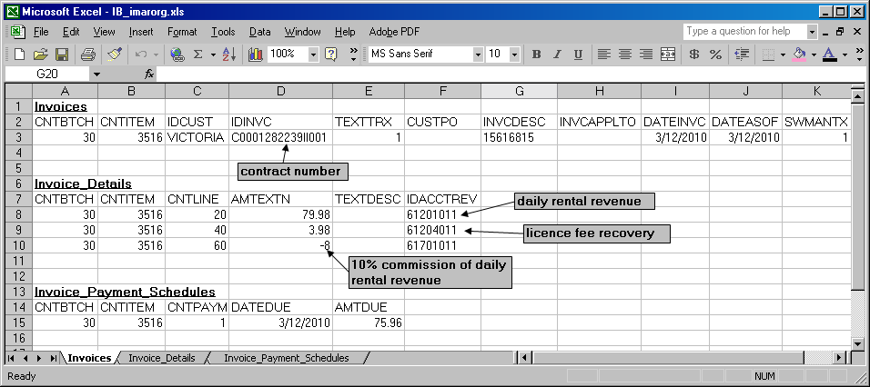
Figure 11: The A/R entries for the local rental are exported to Excel.

3 Exporting IB Entries

Inter-branch entries are generated automatically once business day is closed and are stored in the database. GIS comes with a tool that allows you to export entries to Excel. You can then import these Excel files to ACCPAC for accounting purposes.

You can access the Close Business Day screen from the Admin menu. It is extremely important that no one else is using GIS or processing any payment before you click the Close Business Day button. After we close business day for March 12, the RBR Date field is updated and displays the next business day (See Figure 12).

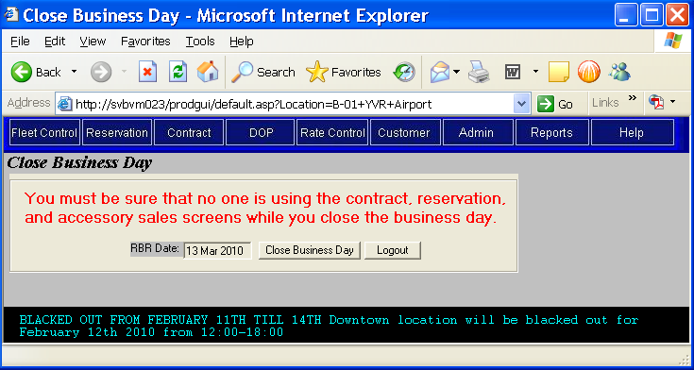
Figure 12: Close business day at the end of the day.

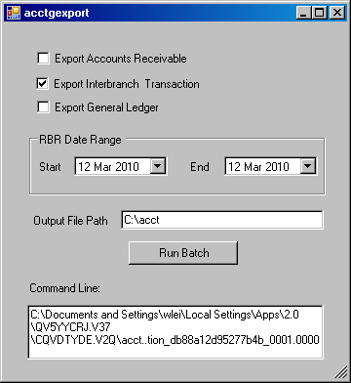
In the next morning, you can export the inter-branch entries to Excel by using the Accounting Export (ACCPAC) tool, which is accessible from the Admin menu. This tool allows for the exporting of A/R, G/L and inter-branch entries to Excel. Check the Export Interbranch Transaction box. Select 12 Mar 2010 as the RBR Date Range because we have closed business day for that date. Specify a directory where you want your Excel files to be stored and click Run Batch. You can ignore the Command Line section.

Figure 13: The Accounting Export (ACCPAC) tool.
A new folder will be created and named by the RBR Date Range (See Figure 14). Note that the files ending with ‘adj’ are always empty because the adjustment function is not implemented in GIS yet. In ACCPAC, import the IB_imarorg.xls file to the Accounts Receivable menu.

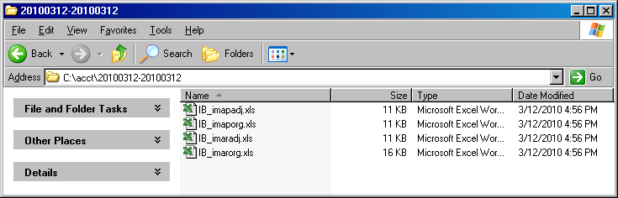
Figure 14: The Excel files are stored in the specified Output File Path.

That sums it up for inter-branch.

